**Website Planning Document for Temple Inn and Suites**

**Site Name:** Temple Inn and Suites By: Traesa Titel

**Domain Name:** InnandSuites4Temple.com CIT 230 Fall 2019

**Website Logo:**



**Site Motto**

*Visit Heaven on Earth and feel right at Home*

**Site Purpose**

The purpose of this website is to provide information to families, missionaries and groups visiting the temple about the accommodations and services offered by Temple Inn and Suites. The site will also provide information about temples in the area and contact information as well as a reservation form. The goal is for the site increase the use of these services and facilities by people coming to the temple.

**Target Audience and Scenarios**

The target audience is Families, Church Groups and Missionaries that will be visiting the temple. Some of the people will be coming from long distance and will need the services in order to come to the temple.

**1st Persona – Retired Couple serving a temple mission - Edna and Frank Rosenthahl**

Senior missionary couple who fulfills their temple assignment on a weekly basis. They are retired and dedicated to serving the Lord in the temple. The will be staying for an entire week and spending the majority of their time in the temple. They will need comfortable and convenient accommodations that allow sleeping, showering and eating. They will need a small kitchenette in order to prepare and eat dinner. They need to be close to the temple in order to reduce travel time and spend their energy in the House of the Lord.

**2nd Persona – a 22 year old newly engaged woman from Kansas – Paula Santos**

Paula met her fiancé while he was on His mission in Kansas. They are planning to be married in his home town of San Diego. Paula and her family of 15 will be traveling to the wedding and are in need of accommodations near the San Diego temple. They also are in need of facilities to host the familiy dinner and a small reception after their wedding ceremony in the temple. Paula has serval younger siblings that will not be able to attend the wedding ceremony but will need a place to be babysat during this time.

**Scenarios**

* Is there a place to change and getting ready for the temple after traveling a distance?
* Is there any babysitting services and facilities near the temple?
* Can we find an affordable place to stay for a week near the temple instead of traveling long distances daily?
* Where can my family stay who is traveling a long distance to come to my wedding?
* Is there a place to host a wedding reception?
* Can youth groups plan a temple trip and have facilities to accommodate meals and overnight stays?

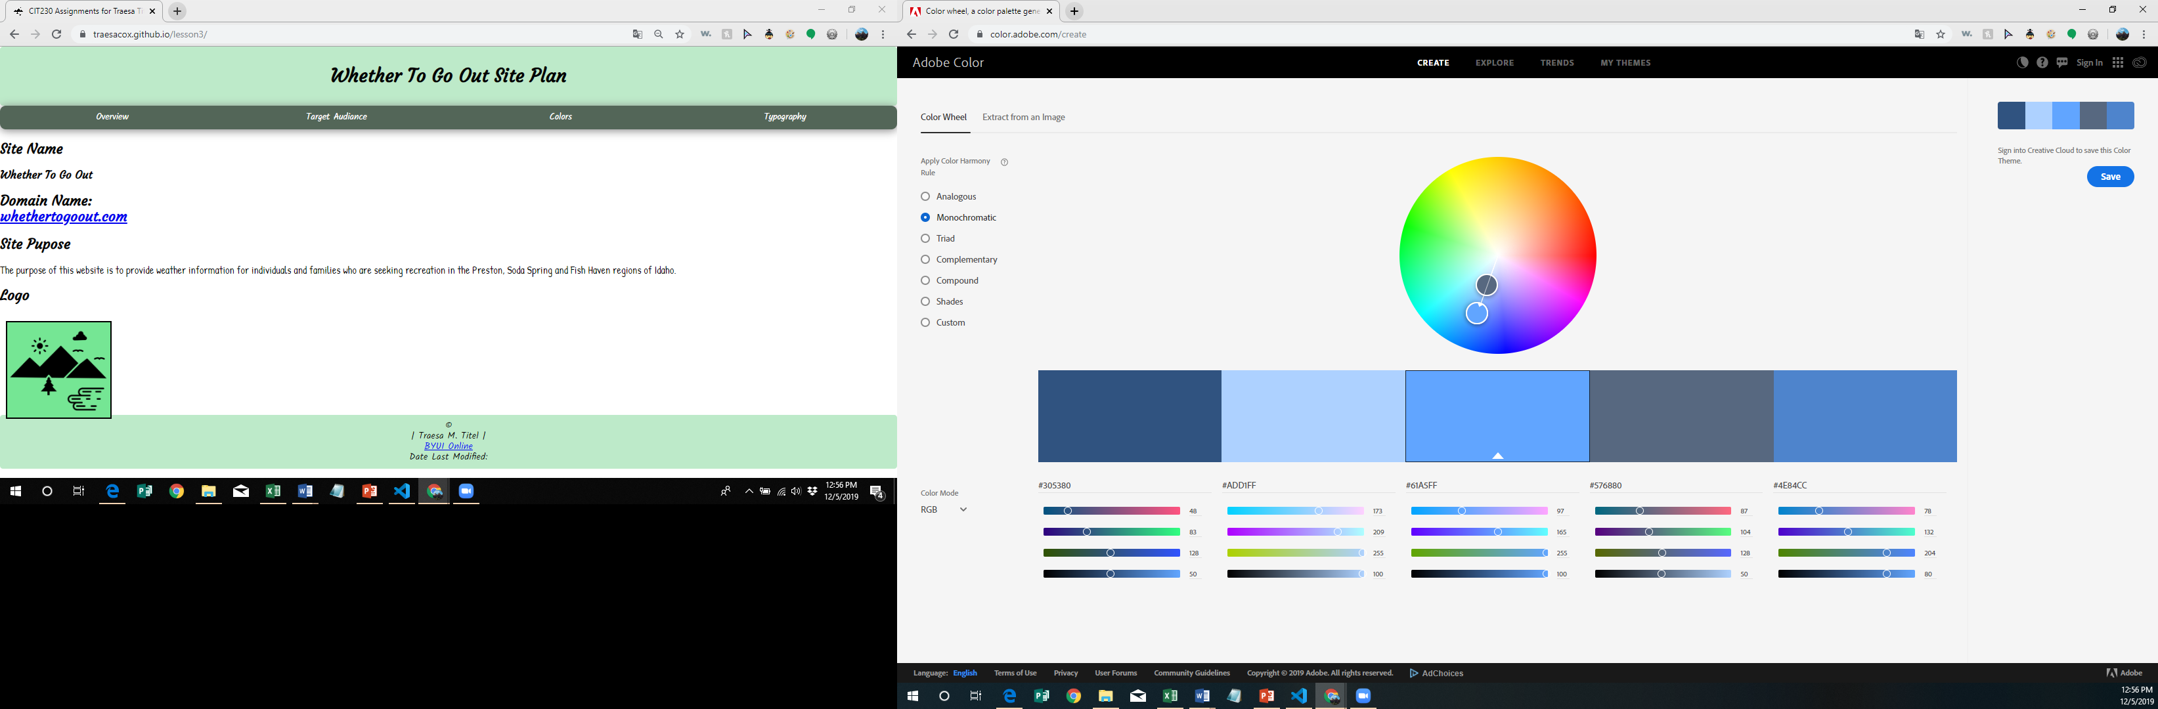**Color Scheme for the Website**

#305380 will be the dominant color on the website. This color will be used for heading and call to action boxes and well and other important features.

#ADD1FF will be used as the background color for the header and footer. This will also be a background option for some of the content boxes.



#576880 will be used as an accent color for borders and dividing lines. I will also be the color on

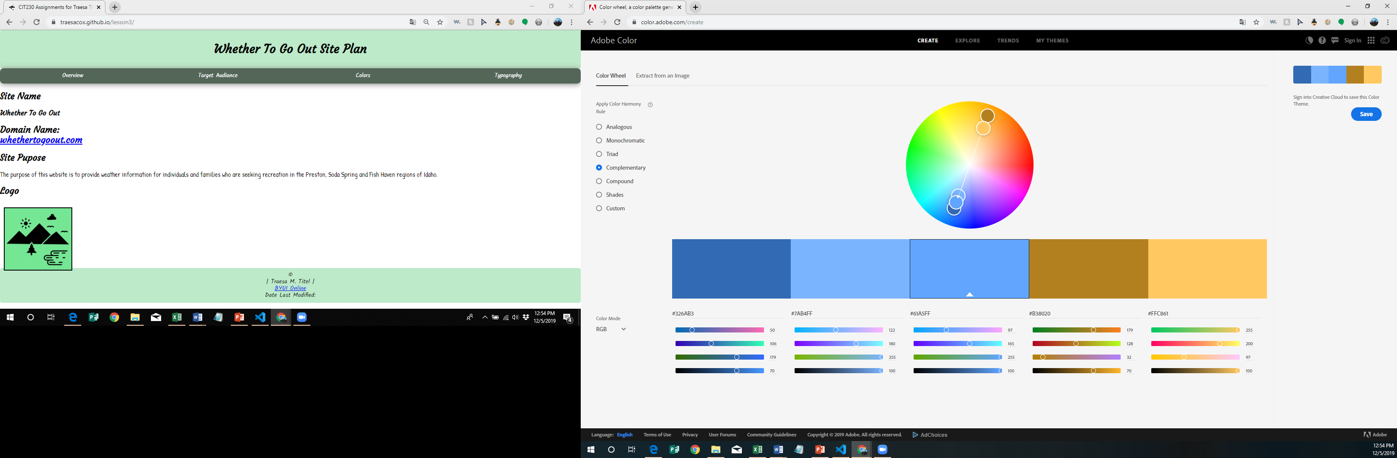

#FFC861 is an accent color that will be used as wayfinding in the navigation as well as on line, borders and outlines.

**Typography**

The fonts that will be used on the website are Fondamento for the Headings, Italianno for accents and special features such as the motto, and Alice for general body text.

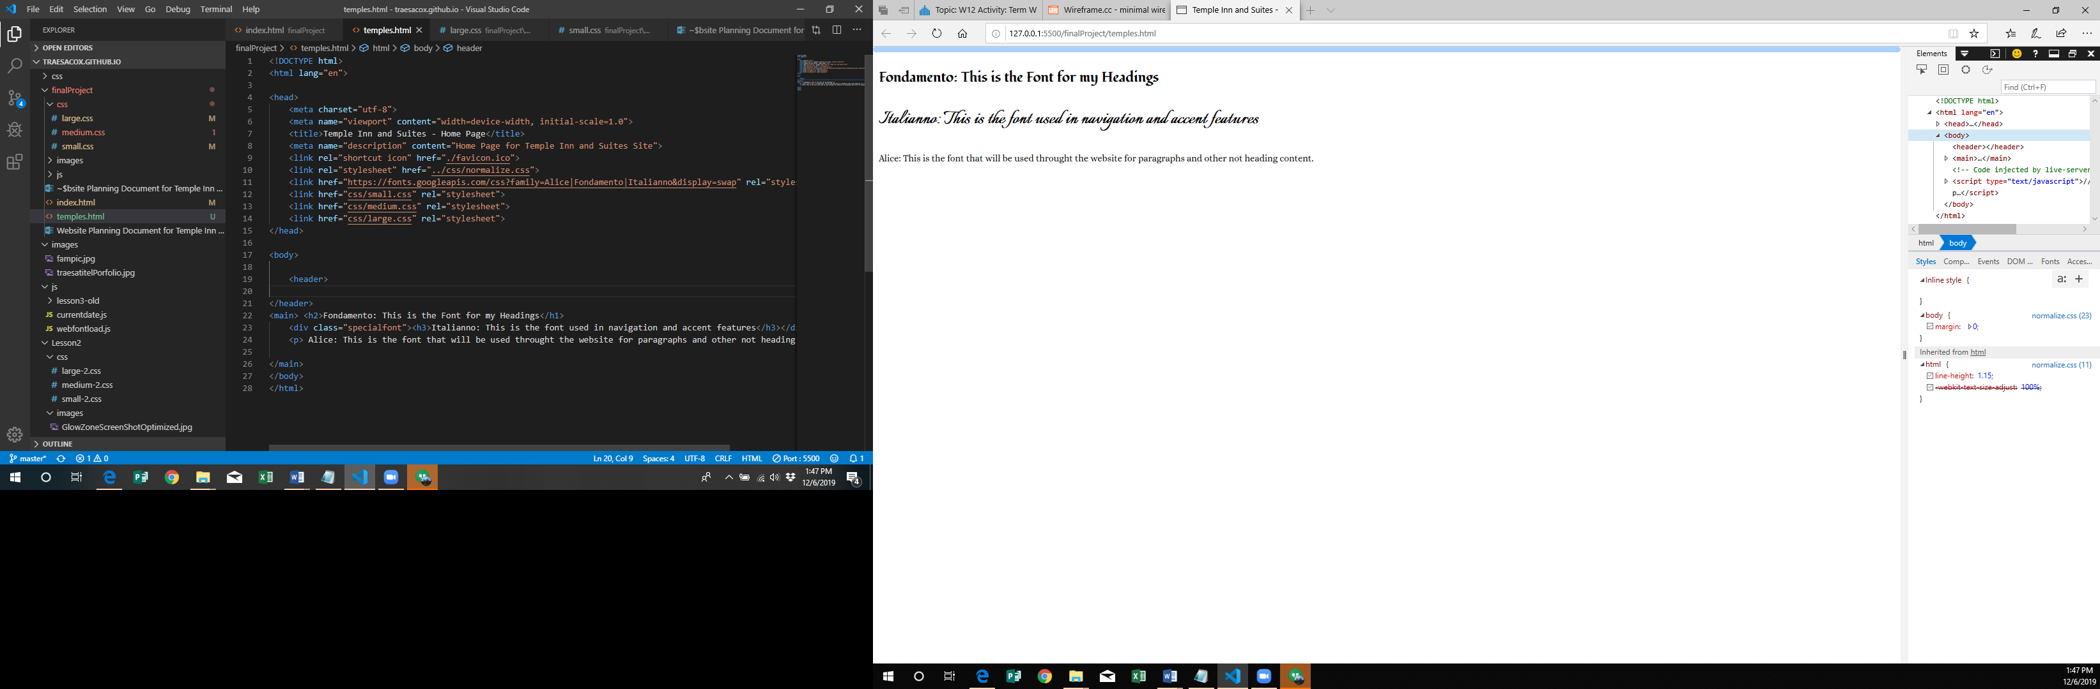

**Site Map**

**Wire Frames for Home Page**

**Large Screen**

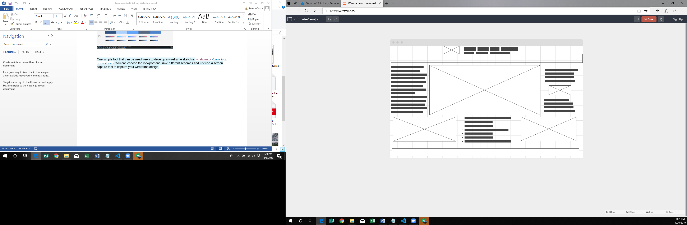

Call to Action Button

**Medium Screen Small Screen**

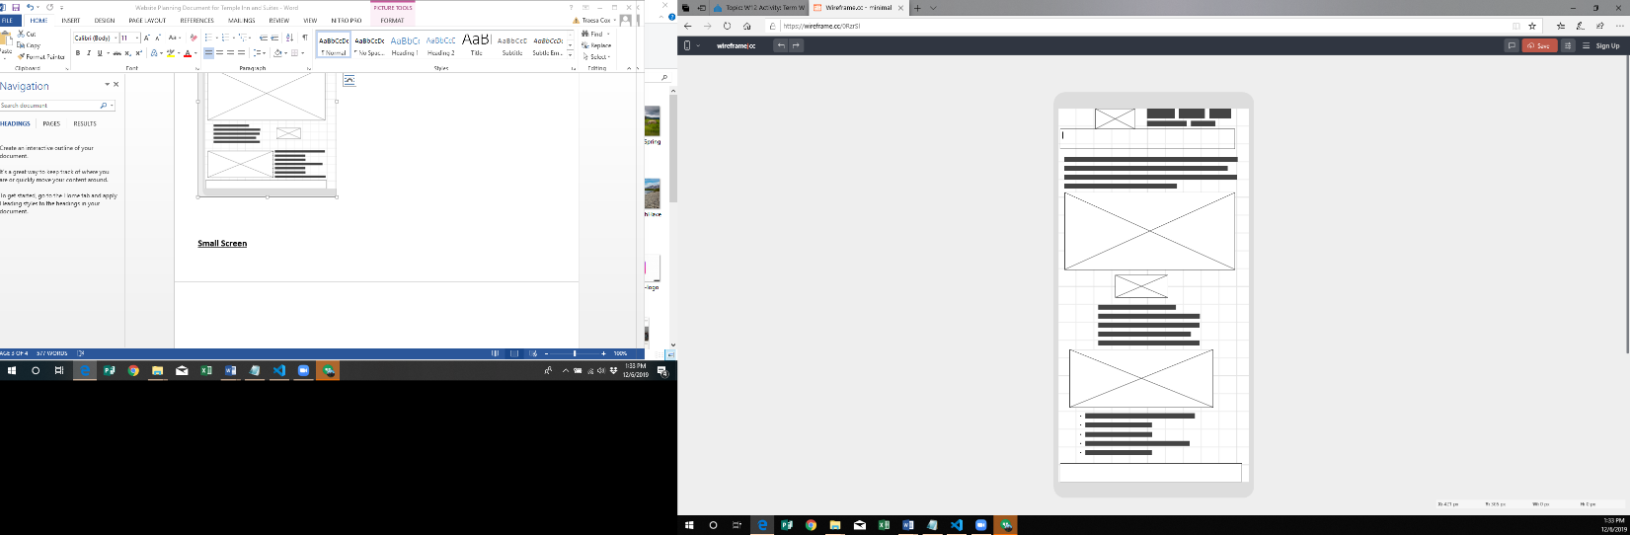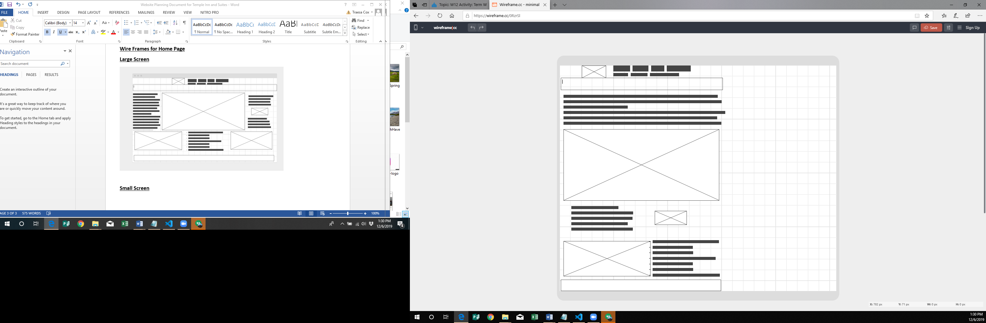

Call to Action Button

Call to Action Button